BRB Building Words Routine
Sound Box Routine | Student | Teacher
Say it | The students repeat the word and say the sounds in the word while watching the teacher’s mouth make the sounds. Students can tap their fingers against their thumb for each sound. | The teacher says the word and then slowly says each sound in the word and taps their thumb and fingers to count the sounds in the word.
Build it | While the students are saying the sounds, they are looking for the letters to build the word using letter tiles. Students place the letter tiles in the sound boxes. | The teacher observes students building the words. Teacher uses error correction routine to support students who have not built the word correctly. After students finish building the word, the teacher builds it on the board in the boxes.
Tap it | Students tap under the letters, looking at the letters, while they say the sound. | Teacher taps under the letters and says the sounds while watching students. Stop and repeat the tap it if any of the students are not both looking at the letters and making the sounds.
Swipe it | Immediately after tapping the sounds through the word two times, move the pointer finger under the letters to blend the sounds into a word. | Immediately after tapping the sounds through the word two times with the second one faster, move the pointer finger under the letters to blend the sounds into a word. If students need support, do one swipe slowly and then one swipe quickly.
Write it | Students write the letters in the sound boxes under the letter tiles. | After students write the letters, teachers write the word with the word families on the board.

BRB Word Building Routine
Sound Box Routine | Student | Teacher
Say it | 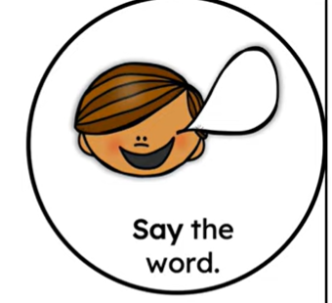 | 
Build it | 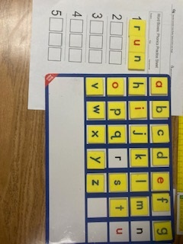 | 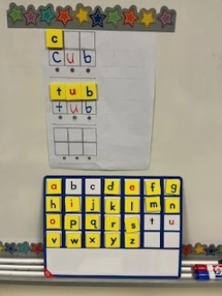
Tap it | 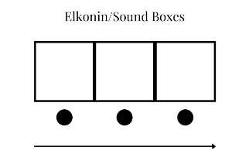 | 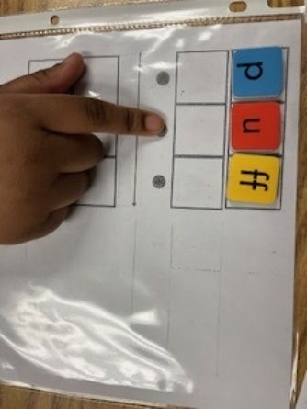
Swipe it |  | 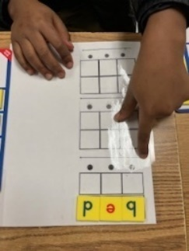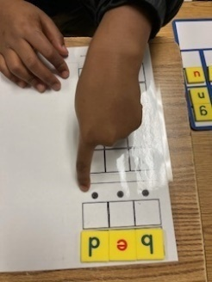
Write it | 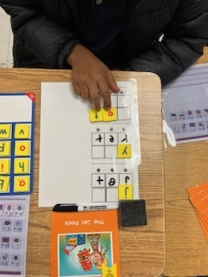 | 